ACKNOWLEDGEMENTS
I would like to convey my heartfelt gratitude to the management and principal
Dr. K. Apparao for providing the financial assistance. I would also like to thank Dr.
Dr. S. Pichi Reddy, Dean R&D for his support during the implementation of the project at various levels.
I would like to express my profound gratitude to Dr. O. Rama Devi, Professor and Head of the Department of Artificial Intelligence and Data Science, for her unwavering support, expert guidance, and encouragement throughout the course of this research. Her insightful feedback, meticulous supervision, and facilitation of the necessary laboratory infrastructure played a pivotal role in the successful execution of this work.
I would also like to acknowledge my peers for their constructive suggestions and collaborative spirit, which greatly enriched the research experience.
Finally, I would like to convey my special thanks to the students who were involved in the implementation of the project with their efforts and hard work. The completion of the project would not have been possible without their involvement and efforts.

PROJECT COMPLETION REPORT
- Title of the project: Smart City Sensing through Federated Learning
- Principal Investigator(s) and Co-Investigator(s): Mr. Narendra Babu Pamula

- Implementing Department (s): Artificial Intelligence and Data Science
- Date of commencement: 21st April 2024

- Planned date of completion: August 2025
- Actual date of completion: May 2025

- Objectives as stated in the project proposal:
Traffic Control, Pollution and Oxygen in Smart Cities: A Federated Learning Approach" is a promising concept that can help address critical urban challenges.
- Reduce Air Pollution Levels
- Improve Air Quality
- Optimize Traffic Flow
- Optimize Public Transportation
- Increase Green Spaces
These objectives can serve as a foundation for designing and implementing a federated learning approach to address pollution, oxygen levels, and traffic control in smart cities, ultimately leading to a cleaner, healthier, and more sustainable urban environment.

- Deviation made from original objectives if any, while implementing the project and reasons thereof:
One of the main objectives of the project is to Traffic Control, Pollution and Oxygen in Smart Cities: A Federated Learning Approach" is a promising concept that can help address critical urban challenges. But in our model, we have taken the only

- Experimental work giving full details of experimental set up, methods adopted, data collected supported by necessary table, charts, diagrams & photographs:

  - Experimental set up:
The experimental hardware in this project consists of an intelligent environmental monitoring module designed using a combination of IoT sensors and a NodeMCU (ESP8266) microcontroller. The objective is to detect various air quality parameters in real-time and wirelessly transmit the data for further analysis.

The setup features sensors like the Nova PM Sensor SDS011 for detecting particulate matter (PM2.5 and PM10), the Ozone Gas Sensor for measuring ozone concentration, and the MICS-5524 Gas Sensor for detecting harmful gases such as carbon monoxide, methane, hydrogen, and alcohol vapors. A MEMS gas sensor is also used to monitor VOCs and low-power gas detection.

To enhance the system, additional sensors were integrated, including three DFRobot Gravity O2 Sensors for accurate oxygen level monitoring and three DFRobot Gravity Analog CO2 Sensors (MG-811) to measure carbon dioxide concentration in the environment. These modules improve the system's capability in tracking essential atmospheric gases.

The sensors are all connected to the ESP8266 NodeMCU, which acts as the central control and communication hub. The system is powered using an Orange NMC 18650 Li-ion battery, providing portability and enabling outdoor deployment. A CP2102 USB to UART board is used for programming and serial communication during setup. Male and female connectors, jumper wires, and a breadboard are used to establish flexible and reliable connections, while holding clamps secure the components in place during operation. The NodeMCU connects to a Wi-Fi network and transmits collected data to a cloud platform or local server, supporting real-time monitoring and environmental analysis in urban or industrial locations.
Iot Sensors Used
- Nova PM Sensor SDS011: The SDS011 is a digital air quality sensor that measures particulate matter (PM2.5 and PM10) in the air using laser scattering. It provides accurate and real-time data on dust concentration, useful for monitoring indoor and outdoor air pollution. The sensor communicates via UART and is widely used in IoT air quality monitoring systems.
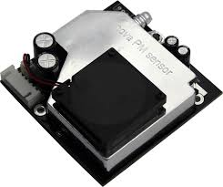
  - Nova PM Sensor
- Ozone Gas Detector sensor: This sensor detects ozone (O₃) gas concentration in the environment. It is typically used in air quality monitoring and industrial applications where ozone levels must be controlled. The sensor outputs analog or digital signals corresponding to ozone levels, helping ensure health and safety.
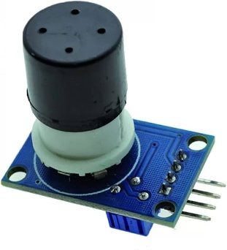
- Ozone Sensor
3. MEMS Gas Sensor: MEMS (Micro-Electro-Mechanical Systems) gas sensors are compact and energy-efficient sensors used to detect gases like CO, NO₂, or VOCs. They work by sensing chemical reactions at the surface of a micro-structured chip. These are ideal for portable and battery-powered IoT devices due to their small size.
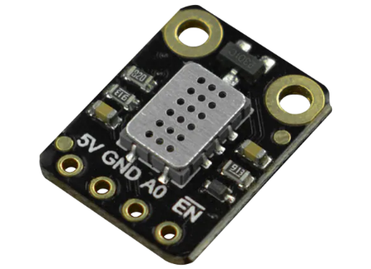
- MEMS Gas Sensor
4. MICS-5524 Gas Sensor: The MICS-5524 is a versatile gas sensor capable of detecting carbon monoxide, methane, hydrogen, and alcohol vapors. It provides both analog and digital output and is commonly used in indoor air quality systems. Its wide gas detection range makes it suitable for home and industrial safety applications.
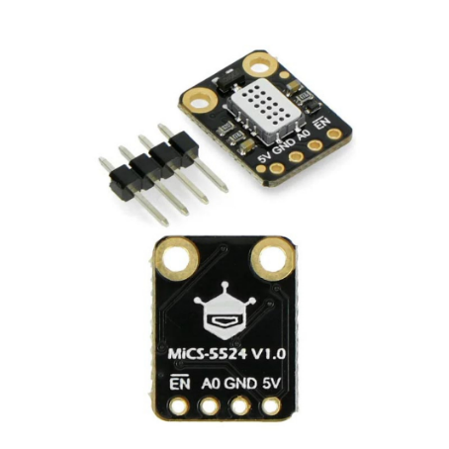
- Mics-5524 Gas Sensor

5.Orange NMC 18650 Li-ion Battery: This rechargeable lithium-ion battery uses NMC (Nickel Manganese Cobalt) chemistry, offering high energy density and long cycle life. The 18650 form factor makes it suitable for powering IoT devices like sensors and microcontrollers. It’s widely used due to its reliability and efficiency.

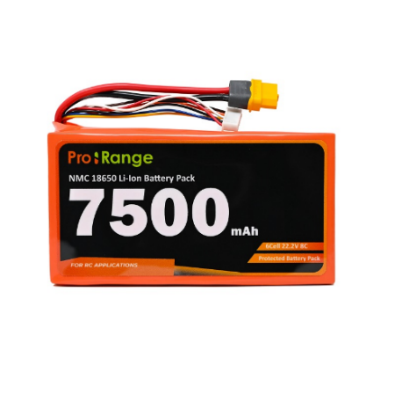
- Battery
6. ESP8266 NodeMCU: NodeMCU is a low-cost Wi-Fi-enabled microcontroller based on the ESP8266 chip. It supports Arduino programming and is ideal for IoT projects due to built-in Wi-Fi and GPIO pins. It allows sensors to connect to the internet for real-time data monitoring and control.
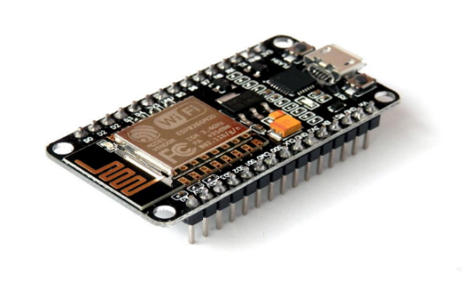
- Node MCU Board
7.Jumper Wires: Jumper wires are used to connect components on a breadboard or microcontroller without soldering. They come in male-to-male, male-to-female, and female-to-female types. These wires are essential for prototyping and testing circuits in IoT projects.
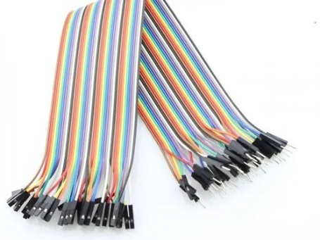
- Jumper Wires
8. DFRobot Gravity: O2 Sensor (Calibrated) – I2C & UART : The DFRobot Gravity O2 sensor is designed to measure oxygen concentration in the air with high accuracy. It supports both I2C and UART communication, making it easy to interface with most microcontrollers. The sensor provides calibrated output and can measure oxygen levels from 0% to 25% in ambient air. It is ideal for environmental monitoring and industrial safety systems.
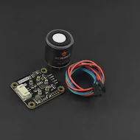

8.DFRobot Gravity O2 Sensor

9. DFRobot Gravity Analog CO2 Gas Sensor (MG-811) : This sensor is used to detect carbon dioxide (CO₂) concentration in the air. Based on the MG-811 module, it provides an analog voltage output proportional to the CO2 levels. It has high sensitivity and fast response time, making it suitable for indoor air quality monitoring, greenhouses, and ventilation control. The sensor requires an external power supply and preheating before giving accurate readings.

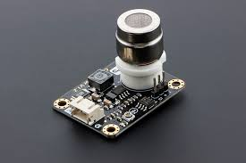


9.DFRobot Gravity Co2 Sensor

10. CP2102 USB to UART Board : The CP2102 module is a USB-to-serial adapter used for serial communication between a computer and microcontroller. It helps in uploading code or communicating with devices like the NodeMCU or Arduino. The board supports USB 2.0 full-speed and has a reliable chip for stable data transmission. It’s commonly used in development and debugging of embedded systems.

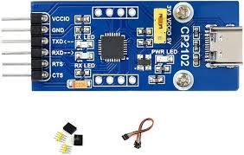

10. CP2102 Board

11. System: HP Victus – 12th Gen Intel Core i7, 15.6 inch : This is a powerful laptop system used for programming, data logging, and analysis. Equipped with a 12th Gen Intel Core i7 processor and a 15.6-inch screen, it provides sufficient performance for compiling code, handling real-time data from sensors, and running cloud dashboards or local analytics tools.



- HP Victus System
12. Connectors (Male & Female) : Male and female connectors are used to establish secure and reliable electrical connections between components. Male connectors have protruding pins, while female connectors have matching sockets to receive them. They are commonly used to link sensors, microcontrollers, and other modules in a modular and removable way without soldering.
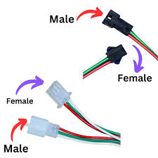
- Connectors
13. Holding Clamps : Holding clamps are mechanical tools used to secure sensors, PCBs, or other components firmly in place during testing or deployment. They help prevent movement or disconnection during operation, ensuring accurate readings and reducing the risk of wire breakage or loose connections.
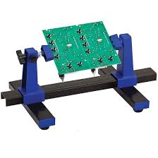
- Holding clamps

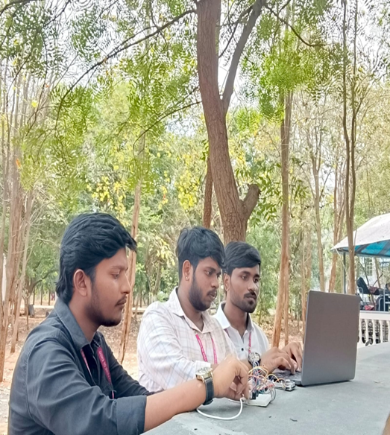

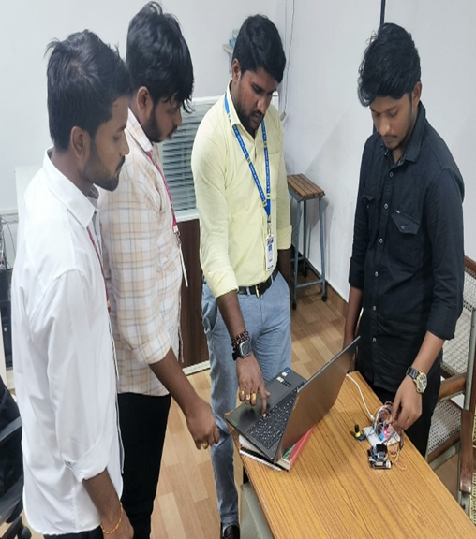

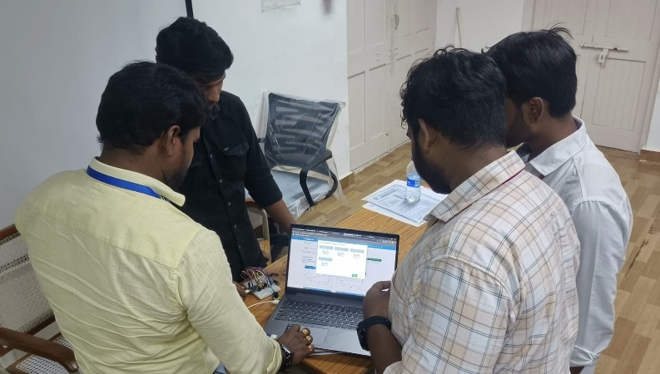

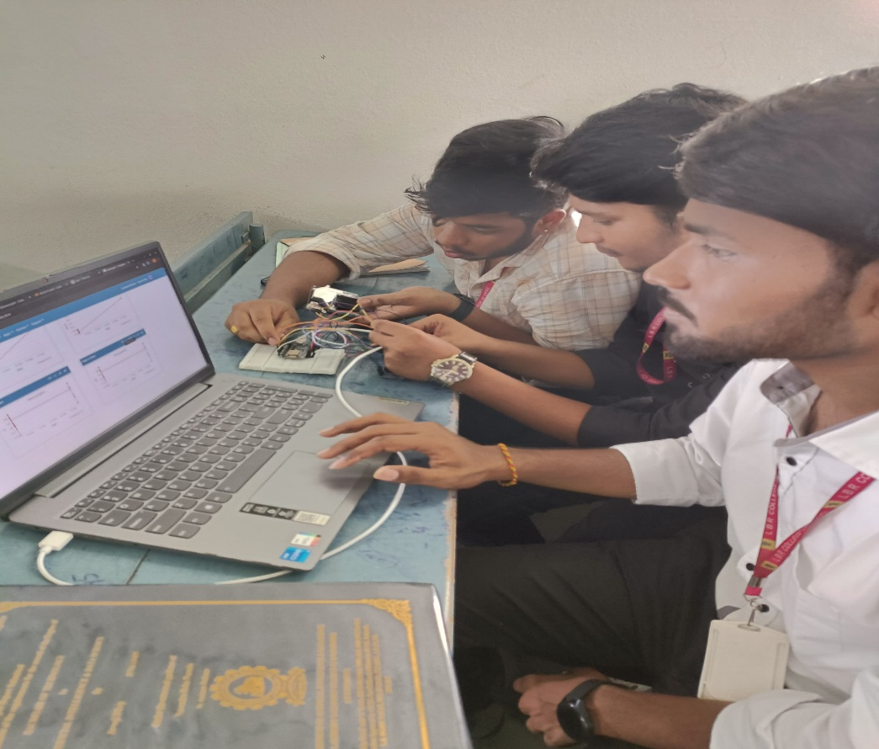

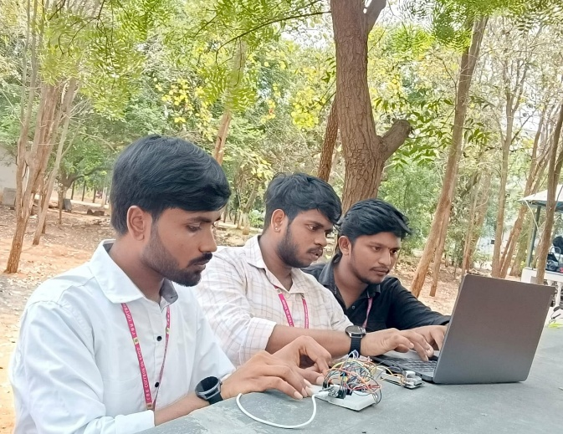

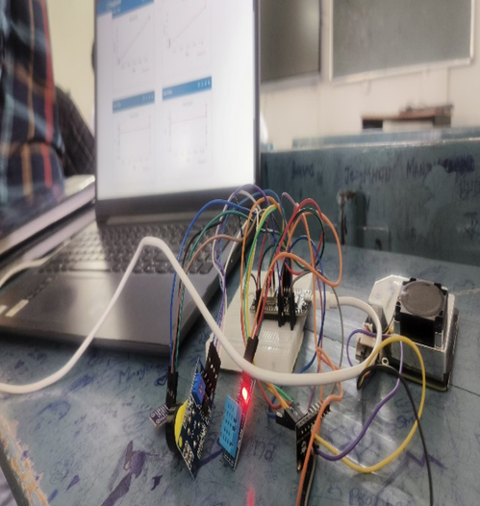

    - CALIBRATION
Calibrating a drone or a controller is the process of setting or correcting errors which caused inaccurate sensor measurements. It checks, adjusts or determines by comparison with a standard model and to make corrections accurately. Drones have a lot of sensors working on to maintain flight efficiency, such as gyro, accelerometer, barometer, magnetometer, etc. You got to make sure these sensors have accurate measurements to fly safely.

For the calibration, we open the Mission Planner software. On the top left corner, we will find an option “Initial setup” and click on it. There are a few procedures that we have to complete, and we click on each option and follow the steps mentioned in each. They are as follows: -

      - Thing Speak Window

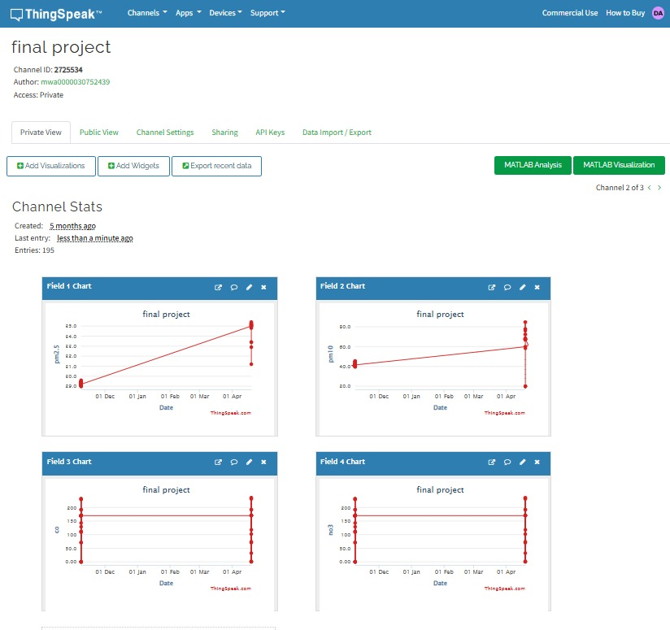

Figure: Thing Speak Window

  - Methods Adopted:
In this project, we used Transfer Learning algorithm to get better results. The idea behind transfer learning is that knowledge gained from the first task can be transferred and used to improve the performance on the second task. This is particularly useful when the second task needs a lot of labeled data or when the second task is like the first task but with minor modifications.

Transfer learning has been broadly used in various applications, including natural language processing, speech recognition, and computer vision. It has also been applied to deep learning models, such as recurrent neural networks
(RNNs), CNNs (convolutional neural networks), and transformers, where pre- trained models are often used as a starting point for new tasks.
This technique helps us to decrease the processing time. There are a lot of modules in the algorithm such as ResNet50, ResNet152V2, InceptionV3 to get better results. Among these, we decided to use the inceptionV3 module due to the consideration of the parameters in those modules. For example, consider ResNet50, which has 25 million parameters which is the capacity of processing and in the ResNet152V2 we have 60 million parameters and in the inceptionV3 we have 23 million parameters.

Data Collected Supported by Necessary Table, Charts, Diagrams & Photographs:

Training Dataset: Training dataset consisting of three classes such as Healthy- Crop, Unhealthy Crop, Intermediate healthy Crop (partial damaged crop or recovering crop from disease or pest attack)

When we compare the three, we have fewer parameters in the inceptionV3 it will take less processing time and get good accurate results when compared to other modules.

Crop Health Prediction Module
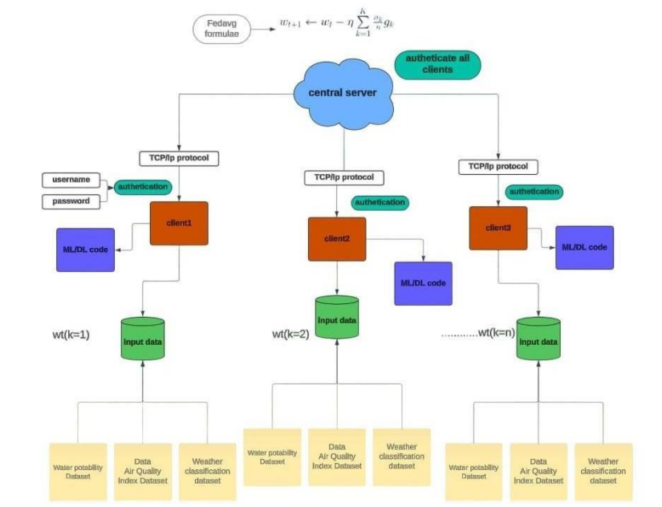
Fig: Model Design Architecture

Dataset Preparation:
A plant health dataset containing temporal and environmental features was loaded and explored. Data cleaning included handling missing values, duplicate rows, and statistical outlier detection using Z-score. Categorical variables, including Plant_Health_Status, were encoded into numerical values using a custom mapping.

Feature Engineering:
Temporal features were analysed by resampling data into daily and weekly aggregates for key environmental metrics (e.g., soil moisture, temperature). Correlation analysis identified features significantly related to plant health.

Data Splitting and Scaling:
The dataset was split into training and testing subsets (80:20 split), ensuring class balance using stratified sampling. Features were standardized using Standard Scaler for improved model performance.
Model Training and Evaluation:
Six classifiers—KNN, DT, RF, GB, LR, and SVM—were trained on the data. Models were evaluated using metrics. The best-performing model was identified based on AUC and accuracy scores.

Visualization:
Data distribution and feature importance were visualized using histograms, heatmaps, and bar charts. Model predictions were compared against actual values with distribution plots and confusion matrices.

Result Summary:
A comprehensive evaluation summary of all models was generated, highlighting the best model. Feature importance and prediction distributions were plotted to interpret the model’s decisions.
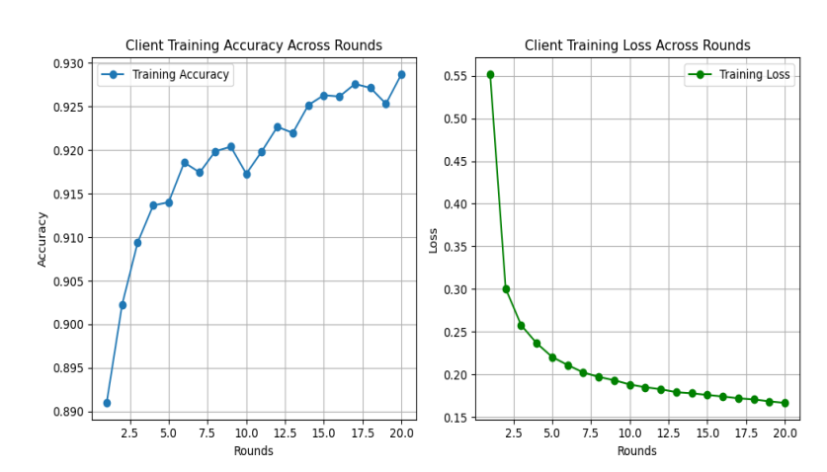
Figure: Client 1 Performance
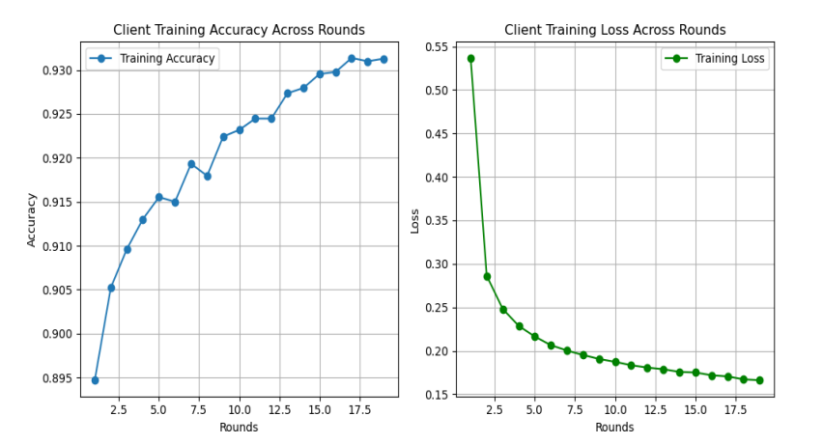
Figure: Client 2 Performance
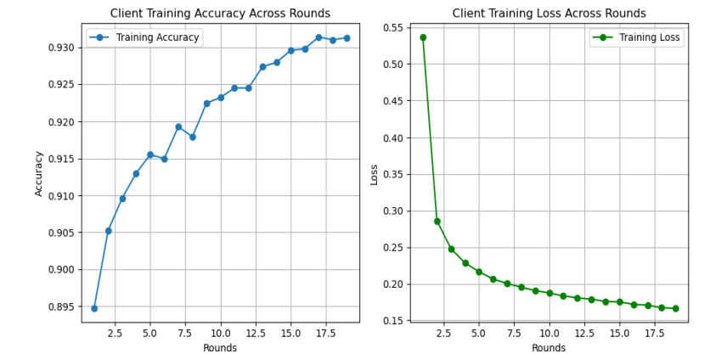

Figure: Client 3 Performance

The existing practice of Crop health monitoring and yield predictions use traditional approaches, the proposed approach in this project helps farmers in acquiring the present status of their crops using UAV. This reduces hard work and, manpower. It also helps to predict the yielding of crops efficiently by using current state-of-the-art techniques.

By adopting the procedures proposed in this project the farmers can avoid health hazards that may be caused by inhaling the toxic chemicals used in the farming. This method can also help farmers in protecting themselves from poisonous creatures such as snakes, scorpions etc.

- Conclusions summarizing the achievements and indication of scope for future work:

The future scope of the project is when we consider two pictures we can get some common part, we can try to avoid the consideration of portion for a good outcome. The crop can have both healthy and unhealthy portions at the time of declaration, we only declare either of them. We will neglect the remaining. So, we do these ideas for further proceeding. In addition to its potential applications in agriculture, making the necessity of deep learning for the estimation of crop yields based on damages has the potential to be applied in other areas, such as forestry, where it could be used to anticipate the amount of timber utilizing the presence and severity of damage caused by pests, diseases, and other factors.
We proposed an approach to demonstrate the use of deep learning techniques that provide valuable information for predicting crop health. The transfer learning approach was effective in enhancing and improving the model and its accuracy, which was shown through the evaluation of the model on a labeled dataset containing images of healthy and damaged crops. This research highlights the importance of using advanced technologies like deep learning in agriculture to support decision-making and improve crop health.

- S&T benefits accrued:

- List of Research publications

S No | Authors | Title of paper | Journal Name | Date of Published
1. | Mr. Narendra Babu Pamula | Federated Learning Integration to Build Robust Urban Intelligence for Smart Cities | KeAi: Global Transitions | Jan 2025
- Manpower trained on the project.
  - Research Scientists or Research Associates : NIL

  - No. of Ph.D. produced : NIL
  - Other Technical Personnel trained :

Sno | Reg. No | Name | Class of Study | Ph.NO | email
1 | 21761A5415 | Javvaji Dileep | IV B. Tech | 9398608162 | dileep.javvaji143@gmail.com
2 | 21761A5414 | Jamili V G S K Rishi Kumar | IV B. Tech | 9493081816 | chintu193810@gmail.com
3 | 21761A5404 | Avanigadda Durga Sankar | IV B. Tech | 8125833907 | sudhaavanigadda550@gmail.com
- Patents taken, if any : NIL

- Financial Position:

S No | Financial Position/ Budget Head | Funds Sanctioned | Expenditure | % of Total cost
i. | Salaries/ Manpower costs
ii. | Equipment | 43, 000 | 43,000 | 100
iii. | Supplies & Materials |  | 18,600 | 53
iv. | Contingencies | 20,000
v. | Travel | 10,000
vi. | Overhead Expenses
vii. | Others, if any | 20,000
 | Total | 93,000 | 61,600 | 66

- Procurement/ Usage of Equipment
a)
S No | Name of Equipment | Make/Model | Quantity | Unit Price | Amount | Invoice/  Date of purchase
1 | DF Robot Gravity: | Sensor (Calibrated) – I2C & UART | 02 | ₹26,500 | ₹13,250
2 | CO2 Gas Sensor | Arduino (MG-811 Sensor) | 01 | ₹16,500 | ₹16,500
3 | CP2102 BOARD |  | 01 | ₹ 1600

- Plans for utilizing the equipment facilities in future

  - UAVs can be used to implement a medical transportation system for transferring medicines during emergencies and disasters.
  - The current project uses manual operation of an individual UAV where the system can capture images for a specified task. This can be further improved by adapting self-driving nature to make UAV an autonomous vehicle.

Name and Signature with Date  Dr. O. Rama Devi  (Mentor) | Name and Signature with Date  Mr. Narendra Babu Pamula  (Principal Investigator)

